#### Alysia See

#### February 28th, 2023

#### IT FDN 130A

#### Assignment 07

# SQL Functions

### Introduction

In this assignment, I will be discussing the purpose of using a SQL UPF. I will also be explaining the difference between scalar, inline, and multi-statement functions.

### SQL UDF

A SQL UDF stands for user-defined function and is a way that you create a custom function. The two main basic functions of UDF are functions that return a table of values and functions that return a single value. Creating a UDF will save you time as you can continue to use it.

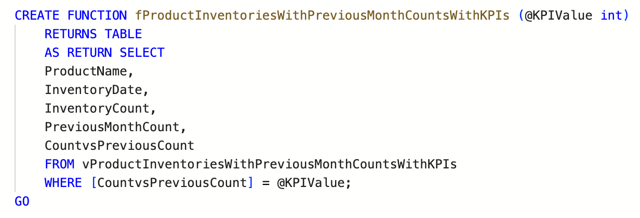

### Scaler, Inline, and Multi-statement Functions

A Scalar function will return a single value. You can set up one or more parameters on table values to return a single value. Inline functions are a way to return a table of values. A multi-statement function is a way to return a table that has multiple select statements.

### Summary

In conclusion, SQL functions are helpful to use as it will save you time from having to re-write code.